Name: ____________________________________ Class: _____________



JURONG PIONEER JUNIOR COLLEGE
JC2 Preliminary Examination 2024

GEOGRAPHY 8834/01

Higher 1 10 September 2024

Paper 1 3 hours

Additional materials: Writing Paper
Insert

READ THESE INSTRUCTIONS FIRST
Write your name and civics class on all the work you hand in.
Write in dark blue or black pen on both sides of the paper.
You may use an HB pencil for any diagrams or graphs.
Do not use staples, paper clips, glue or correction fluid.
Answer Question 1 in Section A.
Answer both questions in Section B.
Answer two questions in Section C.

At the end of the examination, fasten all your work securely together.
The number of marks is given in brackets [ ] at the end of each question or part question.

This document consists of 4 printed pages.
[Turn over
Section A
[Turn over
[Turn over

Cluster 2: Fieldwork
1 | Ang Mo Kio is Singapore’s first cycling town, designed to promote cycling as a sustainable mode of transportation. Initial construction was completed in 2016, with ongoing works expected to finish by 2025. These efforts include increasing the length and interlinking of dedicated cycle paths to encourage cycling. The initiative underscores the importance of sustainable transportation in addressing climate change at the community level.  A group of 10 students decided to investigate the factors that can encourage the use of bicycles for commuting within Ang Mo Kio. They designed the following hypothesis for their study:  ‘The promotion of cycling in Ang Mo Kio has been effective in changing commuting habits in the neighbourhood.’  The students crafted a questionnaire as shown in Resource 3. They planned to conduct surveys using the questionnaire on two weekdays in the month of June at five sites in Ang Mo Kio, as shown in Resources 1A and 1B. At each site, 20 respondents would be given five minutes each to respond to the questionnaire. Resource 2 shows survey site 1 in Ang Mo Kio. Resource 4 shows selected results from the survey.
 | (a) | Explain why this hypothesis is appropriate for the investigation.  Award 1 mark for each explanation of why the hypothesis is appropriate, to a maximum of 3 marks.  Award a maximum of 1 additional mark for further development of each explanation, where applicable.  Possible responses include:  - It is at a suitable scale as the investigation is confined within Ang Mo Kio. [1] The scale of investigation is suitable to 10 students. [1 additional mark]  - It is clearly defined as the two variables are stated; promotion of cycling is the dependent, changing commuting habits the independent variable. [1]  - It is researchable because it is possible for students to collect the required data on residents’ perception if the provision of cycling paths has impacted their commuting patterns through survey. [1] | [3]
 | (b) | Using Resources 1A and 1B, suggest why site 1 might be a better location than the other sites for the student to conduct the survey.  Award 1 mark for each explanation of why site 1 might be a better location, to a maximum of 4 marks.  Award a maximum of 1 additional mark for further development of each explanation, where applicable.  Award 1 mark of each explanation of the limitation of other sites, to a maximum of 2 marks.  Possible responses include:  - As seen in Resource 1B, Site 1 is a ‘multi-functional site’ with services that cater to a diverse and large number of people. [1] As seen in Resource 1A, Site 1 is also near a MRT station. This will provide a wider range of respondents who possibly use different modes of transportation and able to survey beyond those who only commute by bicycles. [1 additional mark]  - Site 1 is next to a cycling path and bus interchange, and there would be commuters who can provide more accurate perception on how the provision of cycling paths have changed their commuting habits such as cycling from bus interchange to their homes. [1]  - Site 3 was at the end of a small road and the foot traffic might be lower. [1]  - Site 4 was at the entrance of a large carpark that is likely frequented by car users rather than those who cycle. [1] This would limit the relevance of the responses, as the participants may not have substantial experience or opinions on cycling or other mode of transportation such as public transport. [1 additional mark] | [4]
 | (c) | Explain a suitable sampling method to select survey participants.  Award 1 mark for each explanation of a suitable sampling method.  Award a maximum of 1 additional mark for further development of each explanation.  Possible responses include:  - Stratified random sampling is an effective method to ensure that different segments of the population are adequately represented in the survey. [1]  - The students have decided on 40 respondents from each site, a sample size of 200. [1]  - And to identify a mix of demographics that can include specific age group, gender, income level, etc. [1]  - They can also identify the possible respondents from public transport users, cyclists and shoppers. [1]  - Ensure that each strata have an equal quota at each site. This helps to ensure a representative sample. [1] | [4]
 | (d) | With reference to Resource 2, suggest how the students can conduct the research ethically.  Award 1 mark for each explanation of research ethnics.  Award a maximum of 1 additional mark for further development of each explanation.  Possible responses include:  - Obtain Informed Consent: Before starting the survey, clearly explain the purpose of the survey, what it entails, and how the data will be used. [1]  - Voluntary Participation: Emphasize that participation is voluntary and that respondents can choose to withdraw at any time without any consequences. [1]  - Ensure Anonymity: Do not collect any personally identifiable information (e.g., names, addresses). [1]  - Respect Privacy: Avoid asking overly personal or intrusive questions. If sensitive questions are necessary, ensure they are asked in a respectful and non-invasive manner. [1] | [4]
 | (e) | Explain the limitations of the questionnaire as shown in Resource 3. | [5]
Award 1 mark for each limitation of the questionnaire.
Award a maximum of 1 additional mark for further development of each explanation.

Possible responses include:
- There is an overly broad categories of 15 to 64 age group that includes teenagers, young adults, middle-aged adults and those nearing retirement.[1] Each of these sub-groups may have vastly different experiences, needs and perceptions of cycling and public transport. Grouping them together can mask important differences in survey results. [1 additional mark]
- Respondents under 15 category might include children who do not make independent transport decisions. [1] And their responses can skew results and might not provide meaningful data on commuting preferences on cycling. [1 additional mark]
- Having only three response options of ‘strongly agree’, ‘neutral’ and ‘strongly disagree’ will result in limited spectrum of opinions. [1] This could lead to misleading conclusions about the intensity of respondents’ opinions. [1 additional mark]

 | (f) | Using all the resources, evaluate the usefulness of the students’ investigation.  Possible Approaches include:  Candidates could evaluate the investigation by reviewing the methods used to collect data and the data collected in Resource 4. Candidates could review the data collection method, the questionnaire used, and assess the impact on accuracy and reliability of data collected. Evaluation of these methods could include looking at the sample size, whether the samples selected are representative of the resident population in Ang Mo Kio, the range of five different sites as seen in Resources 1 and 2, strengths and weaknesses of the different methods, etc.  Candidates could consider the clarity of the terms used in the questionnaire survey seen in Resource 3 and how these could give rise to differing interpretations by the residents. For instance, to some residents, the feeling of being safe using the cycling path could mean concerns about collisions with other cyclists, pedestrians. It could also mean the condition of the cycling path, such as lighting or surface quality. Candidates could consider how such differing interpretations could affect the conclusions that could be drawn from the analysis of these data in addressing the hypothesis, was well as the accompanying reasons why the hypothesis may be valid/invalid.  Levels marked using Generic Level Descriptors for H1 fieldwork evaluative questions  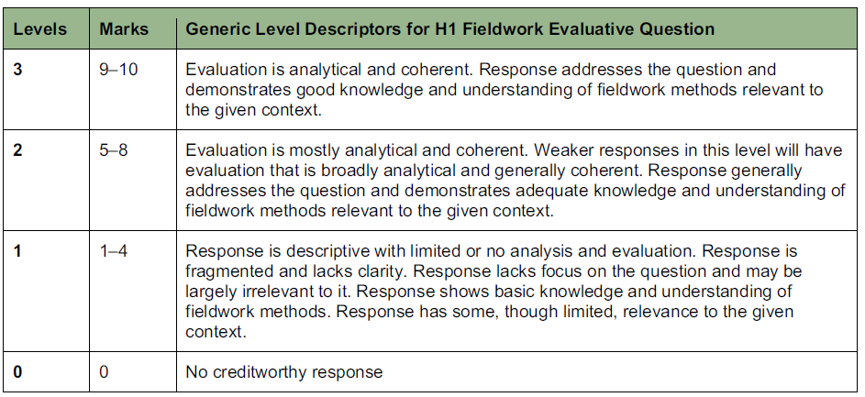 | [10]

Section B
Cluster 1: Sustainable Future and Climate Change
Answer both questions
2 | Resource 5 shows the percentage of the total population that lives in urban areas for selected world regions from 1990 to 2050 (projected). Resource 6A shows the ecological footprints of Athens, Greece and Cairo, Egypt. Resource 6B shows the biocapacity data for Greece and Egypt. Resource 7 shows Athens’ urban sustainability achievements between 2015 – 2023.
 | (a) | Using Resource 5, describe the urban population changes in world regions between 1990 to 2050 (projected).  Award 1 mark for each description of the urban population changes, to a maximum of 4 marks.  Possible responses include:  - There is an overall increase in the percentages of total population living in urban areas from 1990 to 2050. [1]  - The world region that experiences the greatest projected urban population changes is Asia [data]. [1]  - Both Europe and North America experiences the least projected urban population changes [data]. [1]  - The less developed world regions are experiencing a greater projected increase in urban population [data]. [1] |  | [4]
 | (b) | Using Resource 6A, compare the ecological footprint of Athens and Cairo.  Award 1 mark for each comparison of the ecological footprint of Athens and Cairo, to a maximum of 4 marks.  Possible responses include:  - Athens and Cairo’s ecological footprint differs in terms of size. [data]  - One similarity is food is the largest component for Athens and Cairo [data].  - For Athens, personal transportation is the second largest component at 30%, but for Cairo personal transportation and housing are tied for second place at 13%.  - Infrastructure investment is almost similar for both cities, with only a 1% difference. |  | [4]
 | (c) | Using Resources 6A and 6B, describe the relationship between the ecological footprint of each city and the biocapacity of its country.  Award 1 mark for each description of the relationship between the ecological footprint of each city and the biocapacity of its country, to a maximum of 3 marks.  Possible responses include:  - As seen in Resources 6A and 6B, there is a positive relationship between the ecological footprint of the city and the biocapacity of its country. [1] In other words, cities with higher ecological footprint tend to have higher biocapacity.  - The ecological footprint of Athens is 4.84 gha/capita and the biocapacity of Greece is 1.61 gha per person. And the ecological footprint of Cairo is 2.85 gha/capita and the biocapacity of Egypt is at 0.56 gha/capita. [1]  - Athens and Greece has a stronger correlation between the two variables of a 3x difference and Cairo and Egypt has a weaker correlation of a 5x difference. [1] |  | [3]
 | (d) | Suggest ways in which these cities can reduce their ecological footprints.  Award 1 mark for each explanation of how these cities can reduce their ecological footprints.  Award a maximum of 1 additional mark for further development of each explanation in each area.  Possible responses include:  - As seen in Resource 6A, food is the largest component for Athens and Cairo so the cities can encourage local urban farming, promoting local food producers to support sustainable agriculture. [1] The city authorities can implement city-wide programs to reduce food waste, such as composting campaigns. [1 additional mark]  - In the area of personal transportation, the cities can invest in expanding and upgrading public transportation systems to encourage an increase in the use of public transport. [1] Promote the use of EV cars by providing incentives such as tax rebates to reduce the environmental impact of personal transportation. [1 additional mark]  - They can encourage cycling and walking for short distance travel within the city by developing dedicated bike lanes and pedestrian lanes to reduce the use of personal transportation. [1]  - The city authorities can increase the energy efficiency of residential buildings, such as using renewable energy sources such as solar panels. [1] Promote the use of smart home technologies that optimise energy use such as smart thermostats and energy-efficient appliances. [1 additional mark] |  | [5]
 | (e) | With reference to Resources 6 and 7, explain the possible future trends of Athens’ ecological footprint.  Award 1 mark for each explanation of the possible future trends of Athens’ ecological footprint.  Award a maximum of 1 additional mark for further development of each explanation.  Possible responses include:  - As seen in Resource 6A, Athens has a high ecological footprint of 4.84 gha/capita and it is likely that all areas are expected to increase as the city gets more urbanised. [1] A higher level of urbanisation would likely lead to greater demands for resources for housing, transport and industrial development and an increase in ecological footprint. [1 additional mark]  - There is an alternative view that Athens might be able to develop while minimising their future ecological footprint. [1] As seen in Resource 7, Athens have seen success in greenhouse gas emissions reduction and green spaces added from 2015 to 2023. [1 additional mark]  - While personal transportation accounts for a significant 30% of Athens' emissions, the city has demonstrated its ability to reduce greenhouse gas emissions, including those from vehicles. [1] This effort will help lower the carbon footprint, which is a key component of its overall ecological footprint. [1 additional mark]  - The creation of green spaces in the city can help to cool it down by providing shade and releasing moisture into the air, which can help to mitigate urban heat island. [1] This can reduce the use of air-conditioning to help in regulating the city’s temperature, which can help to reduce the ecological footprint. [1 additional mark] |  | [6]

3 | Resource 8 shows contributions of selected greenhouse gases to global warming since 1850. Resource 9 shows projected impacts of climate change for selected continents (millions of people) by 2080.
 | (a) | Explain one natural factor that can influence temperature variability in the Quaternary period.  - Award 1 mark for an explanation of how a natural factor can influence temperature variability.  - Award a maximum of 4 marks for explanation of one natural factor of changing solar output or thermohaline circulation in influencing temperature variability.  Possible responses include:  - Explanation on either changing solar output or thermohaline circulation and how it can influence temperature to vary from glacial to interglacial phases. |  | [4]
 | (b) | Using Resource 8, describe the contribution of the different gases to global warming.  Award 1 mark for each comparison of the contribution of the different gases to global warming, to a maximum of 4 marks.  Possible responses include:  - Overall, carbon dioxide is the gas with the highest contribution of global warming at 69% as compared to methane at 26% and nitrous oxide with the lowest contribution of 5%. [1]  - Carbon dioxide from fossil fuels and industry is the main contributor to 48% of warming at more than nine times higher than nitrous oxide, the least contributor with 5% of warming. [1]  - Carbon dioxide and methane from the burning of fossil fuels and industry contributed to more than 50% of global warming, causing an increase of more than 1°C as compared to carbon dioxide and methane from agriculture and land use of a combined 31% to global warming. [1]  - While both methane and nitrous oxide contributed to a similar rate of 5% of warming but the extent of temperature increase differs by 0.7°C. [1] |  | [4]
 | (c) | Using Resource 8, explain how human factors are contributing to global warming.  Award 1 mark for each explanation of how human factors can contribute to global warming.  Award a maximum of 1 additional mark for further development of each explanation.  Possible responses include:  - As seen in Resource 8, fossil fuels and industry is the human activity that is the main contributor to global warming, releasing both carbon dioxide and methane. The burning of fossil fuels like coal, oil and natural gas for energy, transportation and industrial processes releases large amounts of carbon into the atmosphere. [1] Carbon dioxide is the most significant greenhouse gas, trapping heat and leading to increase in the Earth’s temperature. [1 additional mark]  - As populations grow and standards of living rise, there is an increasing demand for goods and this demand drives the expansion of industrial production to meet consumer needs.[1] To satisfy this demand, industries have adopted mass production which requires significant energy from the use of fossil fuels, thus contributing to release of carbon. [1 additional mark]  - Agriculture and land use is the second human activity that release both carbon dioxide and methane. Livestock farming produces significant amounts of methane through digestive processes in animals and manure management. [1] Deforestation will result in loss of forests as carbon sinks, affecting carbon sequestration as less carbon from the atmosphere is being absorbed through photosynthesis, leading to more carbon in the atmosphere. [1 additional mark] |  | [5]
 | (d) | Using Resource 9, contrast the predicted impacts of climate change on Europe with those on Africa.  Award 1 mark for each comparison of the predicted impacts of climate change on Europe and Africa, to a maximum of 3 marks.  Possible responses include:  - Overall, Africa suffered worse predicted impacts of climate change in all the three areas as compared to Europe. [1]  - The largest difference between the two world regions is in the increase in population at risk of hunger; Africa has an increase of 200 while Europe has zero increase. [1]  - The smallest difference between the two world regions is in the increase in population facing water stress, Africa has almost 1.8 times more than Europe. [1] |  | [3]
 | (e) | Suggest why the major emitters of greenhouse gas emissions may suffer the least impact of climate change.  Award 1 mark for each explanation of why the major emitters of greenhouse gas emissions may suffer the least impact of climate change.  Award a maximum of 1 additional mark for further development of each explanation.  Possible responses include:  - The reasons range from economic social, geographical and institutional.  - Wealth and economic resilience: Major greenhouse emitters are often developed countries or rapidly industrialising nations with strong economies and industries that emit large amounts of greenhouse gases. [1] However, their wealth allow them to invest in climate adaptation measures such as building sea walls, climate-resilient urban planning thus reducing their vulnerability to climate impacts. [1 additional mark]  - Social vulnerability: Major emitters often experience lower levels of economic and/or social inequality, this means smaller groups of marginalised low income groups living in high risk areas, e.g. slum dwellers. [1] With a small marginalised group of individuals, it will reduce the overall exposure to negative climate change impacts. [1 additional mark]  - Strong governance: Countries that are major emitters often have more stable governments that can implement more effective adaptive policies such as creating incentives for sustainable practices thus they suffer a lower level of climate change impact. [1]  - Geographical advantage: Some major emitters are located in regions less prone to severe climate impacts. [1] For example, inland USA states may be less affected by rising sea levels compared to low-lying island nations. [1 additional mark] |  | [6]
Section C

Answer two questions
4 | ‘Urban reimaging is key to achieving sustainable urban development’. Evaluate this statement.  Possible responses include:  Candidates could approach the question by making a judgment on whether urban reimaging is more critical than other strategies through a consideration of criteria such as the scale of urban challenges, the complexity of transforming urban spaces, and the resources needed to reimage cities sustainably.  Candidates could also approach the question by analyzing whether urban reimaging is more or less effective in certain contexts by examining two or more case studies where urban reimaging has been employed alongside other strategies. Candidates could consider contextual factors such as the socio-economic status of the urban area, the level of community involvement, the availability of resources, and the specific environmental challenges faced by the cities in question. For instance, candidates could compare a city that successfully implemented urban reimaging as part of a broader sustainability agenda with another city where urban reimaging played a less significant role due to different priorities or challenges. By analysing potential trade-offs, uncertainties about the impact of urban reimaging, and the resources available, candidates can make a nuanced judgment on the relative importance of urban reimaging in achieving sustainable urban development.  Levels marked using Generic Level Descriptors for H1 essays | [13]
5 | Evaluate the influence of firms in climate change response.  Possible responses include:  Candidates could approach the question by making a judgment on whether the influence of firms is more significant than that of other actors, such as governments and NGOs, through a consideration of criteria such as the scale of their impact, the complexity of responding to climate change, and the resources firms have at their disposal. Candidates could assess how firms contribute to both mitigation and adaptation strategies, such as reducing greenhouse gas emissions, investing in renewable energy, and developing sustainable products. Candidates could also explore the strategies that firms implement to address climate change, such as corporate social responsibility (CSR) initiatives, green technology investments, and partnerships with other stakeholders.  Candidates could also approach the question by making a judgment on whether the influence of firms is more significant in certain contexts than in others by examining two or more case studies where firms have played a key role in climate change response. Candidates could analyze contextual factors such as the regulatory environment, public pressure, and market opportunities, that may have contributed to differences in the effectiveness of firms' climate actions. For instance, candidates could compare a firm operating in a highly regulated market with strong government incentives for sustainability with a firm in a less regulated environment, where voluntary action and consumer demand drive climate initiatives. By analyzing the trade-offs, potential uncertainties about the long-term impact of firms' climate strategies, and the resources firms allocate to these efforts, candidates can make a nuanced judgment on the overall influence of firms in climate change response.  Levels marked using Generic Level Descriptors for H1 essays | [13]
6 | ‘Climate change is the main factor that has increased the multiple deprivations experienced by slum dwellers.’ Evaluate this statement.  Possible responses include:  Candidates could approach the question by making a judgment on whether climate change is more significant than other factors through a consideration of criteria such as the scale of its impact, the complexity of the challenges it poses, and the resources needed to mitigate its effects. Candidates could explore how climate change exacerbates existing vulnerabilities in slum communities, such as poor infrastructure, inadequate access to clean water, and exposure to health risks. Candidates could also assess the role of other factors, such as economic inequality, rapid urbanization, and weak governance, in increasing the deprivations faced by slum dwellers. By comparing the relative influence of climate change against these factors, candidates can evaluate whether climate change is indeed the main driver of increased deprivation or whether it is one of several interconnected challenges.  Candidates could also approach the question by making a judgment on whether climate change is a more significant factor in certain contexts than in others by examining two or more case studies of slum communities that have been impacted by climate change. Candidates could analyse contextual factors such as the geographic location of the slum, the level of resilience in the community, the effectiveness of local governance, and the availability of external support that may have contributed to the differences in the severity of climate-related deprivations. For instance, candidates could compare a coastal slum community that faces frequent flooding due to rising sea levels with an inland slum where extreme heat and water scarcity are more pressing issues. By analysing the potential trade-offs, uncertainties about the long-term impacts of climate change, and the resources available to slum dwellers and their governments, candidates can make a nuanced judgment on whether climate change is the primary factor driving increased multiple deprivations among slum dwellers or whether other factors play a more critical role.  Levels marked using Generic Level Descriptors for H1 essays | [13]

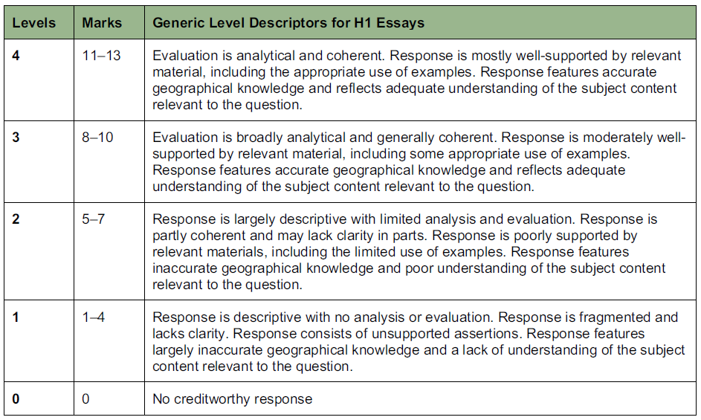

End

